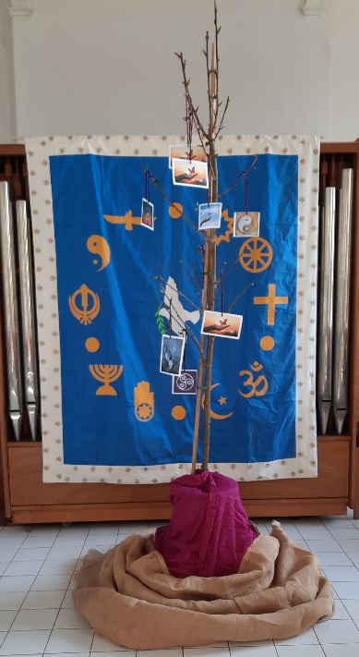Dear Student.

We invite you to join us on our Lenten Journey which began on Ash Wednesday 5th March, and will conclude with our Interfaith Service on Monday 7th April, during convocation time

This Journey can be an opportunity to transform our attitudes towards ourselves, our life, and all those we know and love. An opportunity for healing, to take stock of our life, to-sort-things-out. To get rid of all that slow, or weigh us down. A time for letting-go of all that holds us back, from living our life-to–the-full.

A tree sapling *(Cherry Blossom)* had been placed in the College Chapel, and we invite you to write the names of those you wish to pray for, be it yourself, a family member, or a friend on the cards provides, and to place them on the tree sapling. At the conclusion of our Interfaith Service the tree sapling will be planted in the College grounds.

***Symbols for Healing***

     

***Symbols of Religious Traditions***

 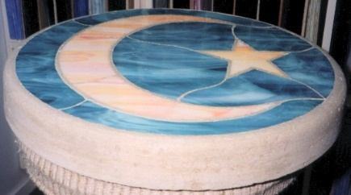 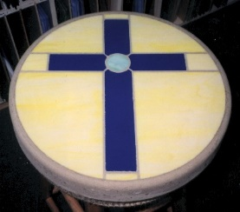  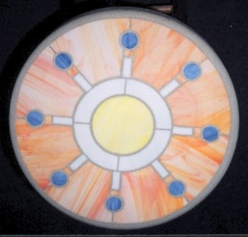

**If you would like to assist in our Inter Faith Service, please contact our Chaplain Liam Dunne.** [**ldunne@carlowcollege.ie**](mailto:ldunne@carlowcollege.ie)