Appendix 1.14: Sample Hybrid Working Risk Assessment / Checklist Form
STEP 3 - Homeworking risk assessment / checklist(This is done by the Assessor with the employee)
Employee Name: |  |  | Address:
Work Activity:
 |  |  | Role:
Assessor Name: |  |  | Manager Name:
Step 1 Equipment / resources required
Dedicated Room |  | Keyboard |  |  | Wrist Rest
Workstation |  | Mouse |  |  | Broadband
Chair |  | Task Lighting |  |  | Mobile Phone
Laptop |  | Docking Station |  |  | Printer
Desktop Computer |  | Document Holder |  |  | Headset
Monitor |  | Footrest
Further Information:

Step 2 – Homeworking risk assessment/checklist
Control | Yes | No | N/A | Comments/ follow up actions
1. Workstation
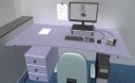
The workstation has adequate space for equipment including mouse, keyboard, laptop, laptop stand, monitor and allows the employee to find a comfortable position.
Is there a dedicated workspace that can be set up in the home that is safe, suitable, and free from distractions?
Is there enough knee clearance underneath the workstation?
Is there enough space to allow the employee to change position and vary movements?
Is the area clutter free so that the employee can focus easily on the task?
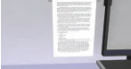
Is a document holder required to read documents?
2. Chair
Control | Yes | No | N/A | Comments/ follow up actions
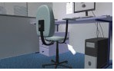
Is the chair provided stable, adjustable in height, allows freedom of movement, and provides lower back support?
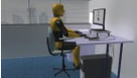
Is the chair set up so that the forearms are level with the desk?
The chair has a back rest which is adjustable in height and the employee has been advised to sit back in their seat in order to get good lumbar support?
Is the chair provided adjustable to allow feet to rest flat on the floor or is a footrest supplied?
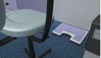
Is a footrest required?
3. Screen
Control | Yes | No | N/A | Comments / Follow Up Actions
Is the screen positioned to avoid glare and reflection (for example sit at 90 degrees to a window to avoid glare)?
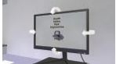
Can the screen swivel and tilt easily?
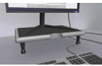
Is the screen positioned so that the top of the screen is
at eye level or slightly below and avoids sustained bending of the neck?
Is the screen free of reflective glare and are reflections liable to cause discomfort?
Is the screen set up at a comfortable distance (for example arm length away)?
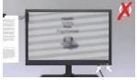
Is the image on the screen stable with no flickering?
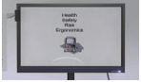
Are the characters on the display screen well defined, clearly formed of adequate size and with adequate spacing?
Has the employee been informed that they should relax their shoulders when viewing the screen?
4. Communications
Is a headset/speaker or microphone provided for communication?
Are arrangements in place to consult with employees and for them to report issues for example accidents, health related issues, workload, faulty equipment, working hours?
5. Keyboard/mouse
Control | Yes | No | N/A | Comments / Follow Up Actions
Is the laptop/PC connected to an external keyboard and mouse?
Is a neutral wrist posture maintained when typing (for example no bending of the wrist)
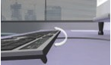
Slope angle of the keyboard can be adjusted so as to allow the employee to find a comfortable position.
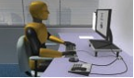
Are the mouse and keyboard within easy reach with space provided in front of the keyboard?
Are wrist rests required?
- Lighting
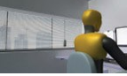
Employee checks suitable lighting (for example natural, task lighting) is available to take account of the type of work being carried out and their vision.
Is task lighting available if required?

- Health
Control | Yes | No | N/A | Comments / Follow Up Actions
Are eye and eyesight tests provided as needed?
Is the employee required to carry out manual handling (If the employee must carry out manual handling activities make sure that employee is trained)
Has the employee been advised to report any musculoskeletal discomfort?
Has the employee been advised to change posture frequently and to stand/move at least every 30 minutes?
Has the employee been advised to avoid back-to-back video calls/online meetings so that they do not sit for extended periods of time?
Are workdays planned so that work can be varied if possible (for example write up notes, take a call away from desk)?
Are there arrangements in place for monitoring and keeping in contact with the home worker?
8. Heating/ventilation
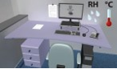
Employee checks the room is warm enough and has adequate ventilation.

9. Electricity
Control | Yes | No | N/A | Comments/ follow up actions
Household electrical supply and equipment for example sockets, lighting, RCD, heaters that are not provided by the employer are checked by the employee on a regular basis.
Is the area around the workstation kept clear of trailing cables and trip hazards?
Is there an adequate number of sockets available?
Is portable electrical equipment provided by the employer checked regularly and is unsafe equipment taken out of use (check for frayed wires, signs of burns or melting)?

- Fire
Homeowner checks firefighting and detection equipment regularly and emergency plan is in place in case of fire
(Fire detection and firefighting equipment is the responsibility of the homeowner).
11. Additional information
Findings

Employee name: |  | Signature: |  | Date:
Assessor name: |  | Signature: |  | Date:
Review date:

Guidance on Working from Home for Employers and Employees, https://www.hsa.ie/eng/publications_and_forms/publications/safety_and_health_management/guidance_on_working_from_home_for_employers_and_employees.html

